User's Manual
GP-80250IVN
THERMAL RECEIPT PRINTER
Proficient in Commercial POS Receipt Printers
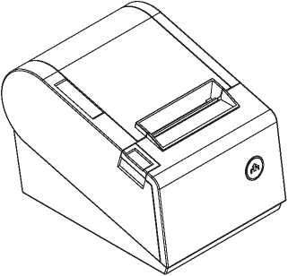

1 .Safety Notice:
- Don't touch the printer head with anything.
- Don't touch the cutter blade.
- Don't bend the power cord excessively or place any heavy objects onto it.
- Don't use the printer when it is out of order. This can cause a fire or and electrocution.
- When connecting or disconnecting the plug, always hold the plug but not the cord.
- Keep the desiccant out of children's reach.
- Use only 叩proved accessories and do not try to disassemble, repair or remodel it by yourself.
- Install the printer on the stable surface. Choose firm, level surface where avoid vibration.
- Don't let water or other foreign objects into the printer.
- Don't connect a telephone line into the peripheral drive connector.
- We recommend that you unplug the printer from the power outlet if no use it for a long period .
- Applications:
- POS system Receipts
- EFT POS system Receipts
- Gym, post, hospital, civil aviation system Receipts
- Inquiry, Service system Receipts
- Instrument test Receipts
- fax, Tab Receipts
- Unpacking
After unpacking the unit, check that all the necessary accessories are included in the package.
User's Manual 1 PCS
Printer 1 PCS
Data Cable 1 PCS
Power Adapter (include power cord) 1 SET
- Features
- 250mm/sec high-speed printing
- High print quality
- Low working noise
- Support cashdrawer kick-out
- Easy maintenance
- Various interface available (Seria+USB+Ethernet/Parallel+USB)
- Built-in data buffer
- Support character enlargement, bold, underline, line spacing and character spacing
- Support NV images download
- Low energy consumption and low operation cost
- Compatible with ESC/POS command set
- Character per line and character set can be set by DIP switches
- Support Ethernet Printing status monitor, multiple connection printing and OPOS printing
- Support printer identification, software binding and high-speed driver mode
- Support various character sets (include GB18030)
- High speed driver printing mode, 66%Improvement in print speed though serial port
- Connect and print Faster, stop receipt misprinting
- Built in web page to setup printer directly

SuddM DaDerend detection
High-speed Printing
Printer Identification

aA
Multiple Connection Printing
OPOS Driver
Various Character Sets
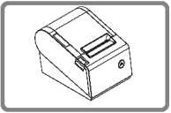
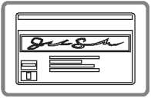
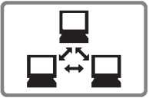

^Specifications
Model | GP-80250IVN
Paper end detection | Support
Printing speed | 250mm/sec
Paper roll | Dimension: width: 79.5 ± 0.5mm Max diameter: 83mm Roll diameter: Inside: 12mm  Outside: Minimum 18mm Maximum 26mm
Printing width | 79.5 ± 0.5mm
Dot pitch | 576dots / line&512dots/ line
Character size | ANK Character,  Font A: 12X24dots,  Font B: 9X 17dots,  Chinese Character: 24 X 24dots
Print command | Compatible with ESC/POS
Interface | Parallel+USB; Serial+Ethemet+USB
Auto cutter | Partial
Reliability print | 150Km
Barcode mode | UPC-A/UPC-E/JAN13(EAN13)/JAN8(EAN8)/  CODE39/ITF/CODABAR/CODE93/CODE128
Paper thickness | 0.06~0.08mm
Powersupply | DC24V/2A
Power adapter | Input: AC110V-220V, 50 〜60HZ  Output: DC24V/2A
Cash drawer | DC24V/1A
Work temperature | Temperature: 0-45°C, Dampness: 10-80%
Storage temperature | Temperature: -10~60T!, Dampness: 10~90%
Dimensions | 210X145X140MM(WXDXH)

s-lo-i—u匸 doEEqlCDU-_1

- Printer Connection
- Plug the DC cord connector into the printer's power connector.
- Plug the data cable connector into the printers interface connector.
- Plug the drawer cable into the drawer kick-out connector on the back of the printer
next to the interface connector.
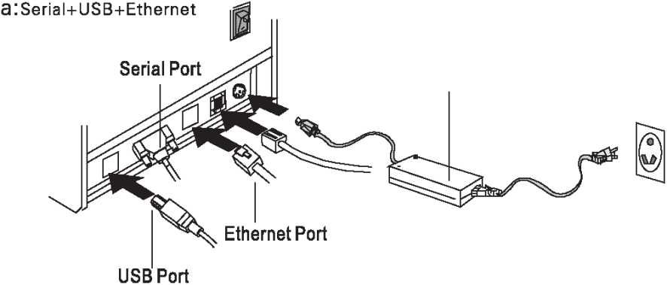

b：Parallel+USB
Cashdrawer Port
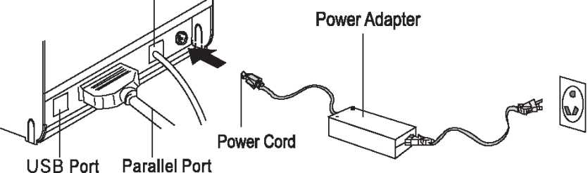

- Installing the roll paper
- Open the printer cover.
- Install the roller in the roll paper, and putthem into the printer.
- Pull out some paper outside the printer and then close the printer cover.
- Close the top cover. Press the printer cover to avoid error position of roll paper.
- lear-off the paper correctly.

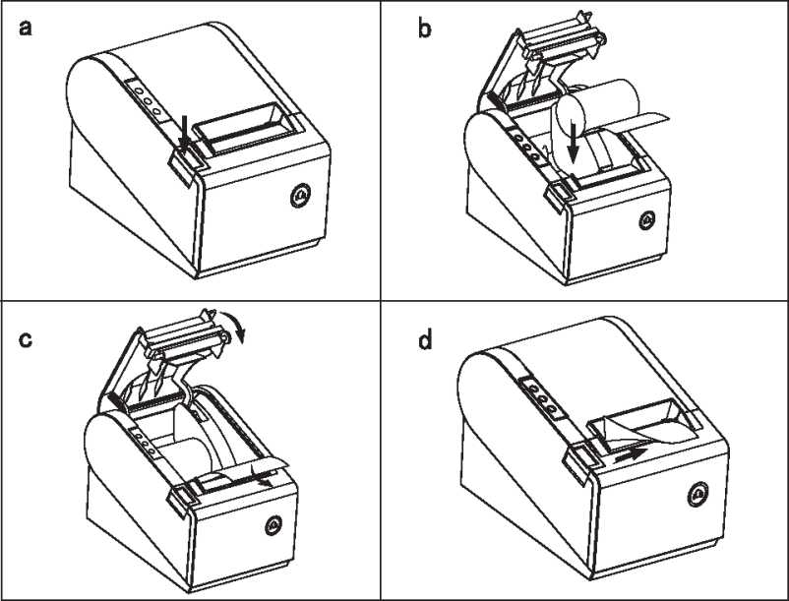
s-lo-l—u_』doE21 eu-_l
- Setting the Printing Mode (DIP switches)
The DIP switches are used to set the printer to perform various functions, such as cutter mode, character set, speed, beeper, print density and etc.
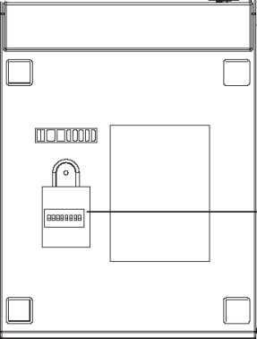

DIP SWITCH SETTINGS

nrino

nnn

1 2 3 4 5 6 7 8
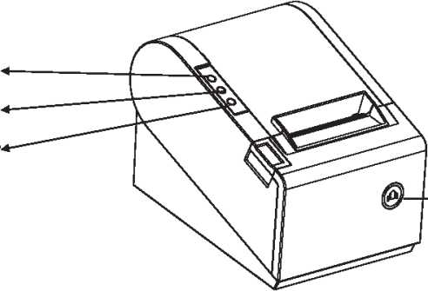
- Buttons and Indicators
Error Indicator
Power Indicator
Power Switch
> FEED Button
- Functions of buttons and indicators
(1) . FEED Button
Press to feed paper manually.
(2) .PAPERIndicator
When this indicator is lighting as well as the ERROR indicator, printer is out of paper. When this indicator is dim as well as the ERROR indicator, printer has paper.
When this indicator is lighting but the ERROR indicator is dim, roll paper is near end.
(3) .POWERIndicator
When this indicator lights, the printer is turned on. When this indicator dims, the printer is turned off.
(4) .ERRORIndicator
When printer is in the status of paper out, cutter error or print head overheat, this indicator is flashing according to user's defined setting.
- Cutter Maintenance
Step (1)
a. Turn off then on the printer, the printer will initialize and reset the cutter.
Step (2)
- Open the front cover.
- Wheel the gear on the cutter to make the cutter back to initial position. Open the printer cover and install roll paper correctly, then the printer works normally.
盅 Caution: Do not open the printer cover by force, so as not to damage the print head and auto cutter.
printer
1. Open the cover by the arrow direction
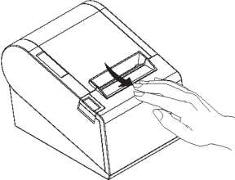
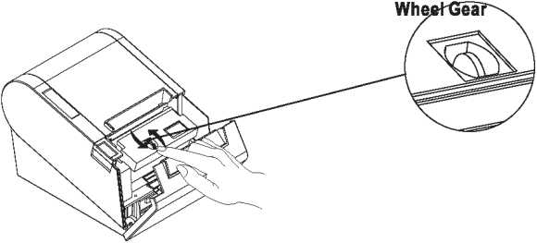

2. Turn the gear to reset the cutter

12. Professional Functions
- 250mm/sec high-speed printing
- Integration of mechianism and cutter
- Support connecting to WAN printing

13. Driver Installation
a. Insert the driver CD disk, run the GP80DRV CN V8 to set up.
褂 Setup - GAINSCHA 80mm Series Printer Driver V8

Welcome to the GAINSCHA 80mm

Series Printer Driver V8 Setup Wizard
This will install GAINSCHA 80mm Series Printer Driver V8 on your computer.
It is recommended that you close all other applications before continuing.
Click Next to continue, or Cancel to exit 5etup.

Next >
Cancel

b. Read and accept the terms to continue the setup
禱 Setup - GAIWSCHA 80mm Series Printer Driver V8
License Agreement
Please read the following important information before continuing.
Please read the following License Agreement. You must accept the terms of this agreement before continuing with the installation.
SOFTWARE LICENSE AGREEMENT
IMPORTArr - PLEASE READ CAREFULLY! The GAINSCHA software you are about to download will be licensed to you, the licensee, on the condition that you agree with GAINSCHA to the terms and condi to ns set forth in this legal agreement. PLEASE READ THIS AGREEMEhTT CAREFULLY. YOU WILL BE BOUND BY THE TERMS OF THIS AGR.EEMETTT IF YOU INSTALL, DOWNLOAD, COPY, OR OTHERWISE USE THE SOFTWARE. If you do not agree to the terms contained in this agreement, please do not install or download the software. Please record the date of download in order to activate the limited ninety (90) day warranty (see below).
⑥ I accept^e agreement
O I de not accept the agreement

c. Select the operation system that you're using, then click next" to continue.

d. Select GP-80250N Series to continue.
压Detail Setting
lx
Install Module IGP-80160N(Cut) Series
Printer Setting
Set Default
GP-8OI6ONQT0 Cut) Series GP-80160N(Cut) Series GP-80220 Qlo Cut) Series GP-80220 (Cut) Series GP-80250 Series
Printer Name
GP-80250N Series
GP-H80250 Series
GP-F80250 Series
S~3xxF Series
< Back
Next >
Exit
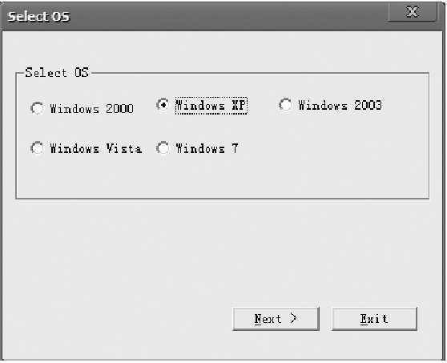

e. Select the corresponding printer port.
Select Port
Speaify Fort
A port is used to connect e. printer to the aomputer.
Specify the port that you are using. If you are connecting using TCP/IP or another port type not listed Lelow, creat a new port.
I F«rt | 1 Typs | 囹1
IUSB002 | I Virtual printer port for | ITSB li
USBOOl | Virtual printer port for | USE
IP_192.168. 123.100 | Standard TCP/IF Port
I 匸192.168. 192.123 | Standard TCT/IF Fort
MiDoc倾ent Im,, | , Local Fort
COM2: | L^cal Port
COM4: | Local Port
FILE： | Local Port
LPT1: | Local Port
 | Crea.tG Fort. | I Configure Fort. . . 1
r

< Back Install Cancel

printer

s」(DPJ_」doE」(Dul(Du_~l

WARNING:
All rights reserved. No part of this publication may be reproduced, stored in a retrieval, or transmitted in any form or by any means, electronic, mechanical, photocopying, recording, or otherwise, without the prior written permission of Gainscha (Hong Kong) International Limited. The company reverses the rights of modifications of manufacture technology, assembly, software and hardware without notice. Contact your franchiser if you need further information about the product.

